**Online Shopping**

**A REPORT**

**ON**

**PRACTICAL TRAINING**

**(For the Partial Fulfillment of Diploma in Computer Science & Engg.)**

**TAKEN AT**

**Javonic Websoft Pvt. Ltd**

**FROM June 1st, 2015 to June 27th, 2015**



**2014-15**

**Submitted to: Submitted By:**

**Mr. Jai Sharma Naresh Mali**

**(Training Incharge) IInd Year**

**Computer Science**

**Department Of Computer Science & Engineering**

**Vidya Bhawan Polytechnic College, Udaipur**

**Vidya Bhawan Polytechnic College, Udaipur**



**Certificate**

**This is certify that the Report entitled “ONLINE SHOPPING” has been undertaken and written under my supervision and it describe the original project work carried out by Naresh Mali S/O Mr. Basanti lal Mali Department of Computer Science & Engineering, VIDYA BHAWAN POLYTECHINC COLLEGE UDAIPUR.**

**Dr. Deepak Gupta Mr. Jai Sharma Prf. Anil Mehta**

**(Name of H.O.D) (Training Incharge) (Name of Principal)**

**Department Of Computer Science & Engineering**

**Vidya Bhawan Polytechnic College, Udaipur**

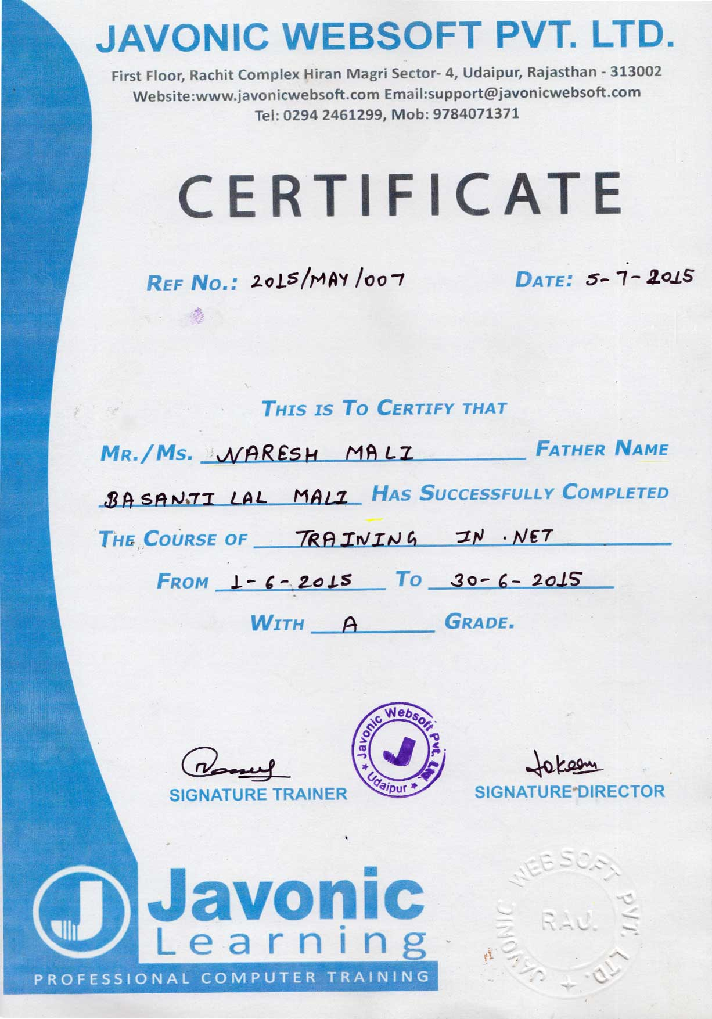

**PREFACE**

The working on the project “**www.Shoppingkart.com**” was an extremely learning experience. I came across no. of new concepts and also enhanced our technical knowledge. I was capable to overcome the position. I have used the ASP.NET in such a manner that this website is friendly with all the browsers like Internet explorer, Chrome, Firefox. Exact now this website is in the testing stage.

I have created a project of **www.Shoppingkart.com** in ASP.Net language. Now a days craze of online shopping in India is increasing rapidly because in present time online shopping is very easy and comfortable. With the use of online shopping we save money and time both so the growth of online shopping user in India day by day increase and many online store currently active which provide best deal and offers online which causes growth of online user increase. In India there are many online site which causes online user increase in India.

Practical training is a way to implement theoretical knowledge to practical use to become a successful engineer, it is necessary to have a sound practical knowledge because it is only way by which one can learn and acquire proficiency.

It is approved fact that bookish knowledge is not sufficient because the things are not as ideal in practical field as they should be.

Project is a special signification for the engineering student, it is special rule too.

We learn to tackle different real world problem that strike while developing any real world computer applications.

The report is an attempt made to study the summer training in Asp.Net and MS SQL SERVER at Javonic Websoft Pvt. Ltd. Sec-4, Hiran Magri, Udaipur (Raj.)

**ACKNOWLEDGEMENT**

**“Task successful makes everyone happy. But the happiness will be gold without glitter if we didn’t state the person who has supported us to make it a success”.**

Success will be crowned to people who made it a reality but the people whose constant guidance and encouragement made it possible will be crowned first on the eve of success. This acknowledgement transcends the reality of formality when we would like to express deep gratitude and respect to all those people behind the screen who guided, inspired and helped us for the completion of our project work.

We want to thank **Dr. Deepak Gupta (Head of Dept.), Mr. Jai Sharma (Project Co Incharge)** and **Mr. Hemchandra Vaishnav** for their full support, cooperation, valuable advice throughout the course of project, which led our project to successful completion.

We want to thanks our parents who have given us this opportunity and family members for their get support and love.

We would express our profound gratitude towards **Mr. Gourav Bhatt (Senior Developer, Javonic WebSoft Pvt. Ltd)** who guided us throughout the project. He supervised our project constantly and inspired us to create user-friendly and robust software. He brought to our notice the problems in our project and inspired us to come up with innovative solutions to overcome the same.

Last but least we would like to thanks all those who have directly or indirectly helped during our project period.

**SUBMITTED BY:**

**Naresh Mali**

**LIST OF FIGURE**

**Figure No. Description of Figure: Page No.**

Figure 1.1: Javonic Websoft Pvt**.** Ltd**.**...........................................................................1

Figure 1.2: Technologies................................................................................................1

Figure 1.3: Why choose Javonic Websoft.....................................................................2

Figure 1.4: Team Work..................................................................................................2

Figure 1.5: Overview.....................................................................................................5

Figure 1.6: Web Development.......................................................................................5

Figure 1.7: Technology..................................................................................................7

Figure 1.8: Latest Project...............................................................................................8

Figure 2.1: Visual Studio 2010.....................................................................................12

Figure 2.2: Architecture................................................................................................14

Figure 2.3: Product Perspective....................................................................................23

Figure 2.4: Working with an ASP.NET Application...................................................29

Figure 3.1: Installation of Visual Studio 2010.............................................................35

Figure 3.2: **Start installation.........................................................................................36**

Figure 3.3: License Terms............................................................................................37

Figure 3.4: Select the Feature.......................................................................................38

Figure 3.5: Start to install its components....................................................................39

Figure 3.6: Installation Complete of Visual Studio 2010.............................................40

Figure 3.7: Home Page.................................................................................................41

Figure 3.8: Men Page...................................................................................................42

Figure 3.9: Women Page..............................................................................................43

Figure 3.10: Latest Offers Page.....................................................................................44

Figure 3.11: About us Page............................................................................................45

Figure 3.12: Contact us Page..........................................................................................46

Figure 3.13: Admin Login Page.....................................................................................47

Figure 3.14: Admin panel Page......................................................................................48

Figure 3.15: Add New Category Page............................................................................49

Figure 3.16: Add New Sub Category Page....................................................................50

Figure 3.17: Add New Product Page..............................................................................51

Figure 3.18: Product Detail Page....................................................................................52

Figure 3.19: Category Table...........................................................................................53

Figure 3.20: Product Table.............................................................................................53

Figure 3.21: Sub Category Table....................................................................................54

Figure 4.1: Software Development Life Cycle.............................................................55

Figure 4.2: Use case.....................................................................................................58

Figure 4.3: input/output flow........................................................................................59

Figure 4.4: Processes....................................................................................................59

Figure 4.5: Representation of entity.............................................................................60

Figure 4.6: Data Collection and process.......................................................................60

**LIST OF TABLE**

**Table No.** **Description of Table Page No.**

Table 2.1: Class Library..............................................................................................16

Table 2.2: Comparison between **.NET** & **JAVA**........................................................17

Table 2.3: Comparison between **ASP** & **ASP.NET**...................................................18

Table 2.4: Comparison between **VB.NET** & **VB**.......................................................19

Table 2.5: Client Side requirements............................................................................23

Table 2.6: Server Side requirements...........................................................................24

Table 2.7: Comparison between **MY SQL** & **SQL SERVER**..................................28

Table 3.1: System Planning........................................................................................33

Table 3.2: Gantt chart.................................................................................................34

Table 4.1: ER-Symbols..............................................................................................54

**LIST OF SYMBOL**

* **RAM :** Random Access Memory.
* **HTTP :** Hyper Text Transfer Protocol.
* **SMTP :**  Simple Mail Transfer protocol.
* **ASP :**  Active Server Page.
* **HTML :** Hyper Text Markup Language.
* **C# :** C Sharp.
* **VB :** Visual Basic.
* **P.D.F** **:** Personal document Format.
* **O.S :** Operating System.
* **ER :** Entity Relationship.
* **CLR :** Common Language Runtime.
* **CSS :** Cascading Style Sheet.
* **CLI :** Common Language Infrastructure.
* **IIS** **:** Internet Information Services.
* **AJAX :** Asynchronous Java Script and XML**.**

**TABLE OF CONTENT**

**TITLE……………………………………………………………………………………..i**

**CERTIFICATE………………………………………………………………………….ii**

**PREFACE ...………………………………………………………………………….….iv**

**ACKNOWLEDGEMENT ...……………………………………………………………v**

**LIST OF FIGURES ...…………………………………………………………………..vi**

**LIST OF TABLE...…..……………………………………………………………..….viii**

**LIST OF SYMBOL…..…………………………………………………………...….....ix**

**LIST OF CONTENT……………………………………………………………….........x**

**LIST OF CONTENT**

**S. No:** **Page No:**

**1**. **Chapter: 1 INTRODUCTION**

1.1 COMPANY PROFILE..........................................................................1

1.2 Why choose Javonic.........................................................................2

1.3 Management & People...........................................................................3

1.4 Excellent Team......................................................................................4

1.5 Overview................................................................................................4

1.6Technologies..........................................................................................5

1.7 How we produce healthy product..........................................................7

1.8 Latest Project.........................................................................................8

**2. Chapter: 2** **MARKET SURVEY**

2.1 ASP.NET...............................................................................................9

2.2 Advantage Using ASP.NET.................................................................10 2.3Difference between ASP.NET & Client-side Language......................10

2.4 C#.........................................................................................................11

2.5 Visual Studio........................................................................................12

2.6 Designing Features...............................................................................13

2.7 Architecture..........................................................................................14

2.8 Comparison..........................................................................................17

2.9 Language Features...............................................................................20

2.10 Application of .NET...........................................................................20

2.11 Characteristics....................................................................................21

2.12 History................................................................................................21

2.13 Definitions..........................................................................................22

2.14 Overall Description............................................................................23

2.15 Product Functions..............................................................................24

2.16 Front-End & Back-End Used.............................................................25

2.17 Specific Requirements.......................................................................26

2.18 Non Functional Requirements...........................................................26

2.19 About Visual Studio 2010..................................................................26

2.20 SQL Server 2008................................................................................27

2.21 Difference between My Sql & Sql Server.........................................28

2.22 Working with an ASP.NET Application...........................................29

2.23 Features of ASP.NET.........................................................................31

**3. CHAPTER: 3 WORK I DID**

3.1 About Project.......................................................................................32

3.2 System Planning..................................................................................33

3.3 Installation of Visual Studio 2010.......................................................35

3.4 Designing of Project............................................................................41

3.5 Designing of Admin Panel.....................................................................47

3.6 Designing of Database.........................................................................53

**4. CHAPTER: 4** DESIGN AND METHODLOGY

4.1 Software Development Life Cycle.......................................................55

4.2 Data Flow Diagrams............................................................................58

4.3 E-R Symbols........................................................................................61

**5**. **SUMMARY & CONCLUSION**

**6**. **RESULT & FUTURE ENHANCEMENT**

**7**. **REFERENCE**